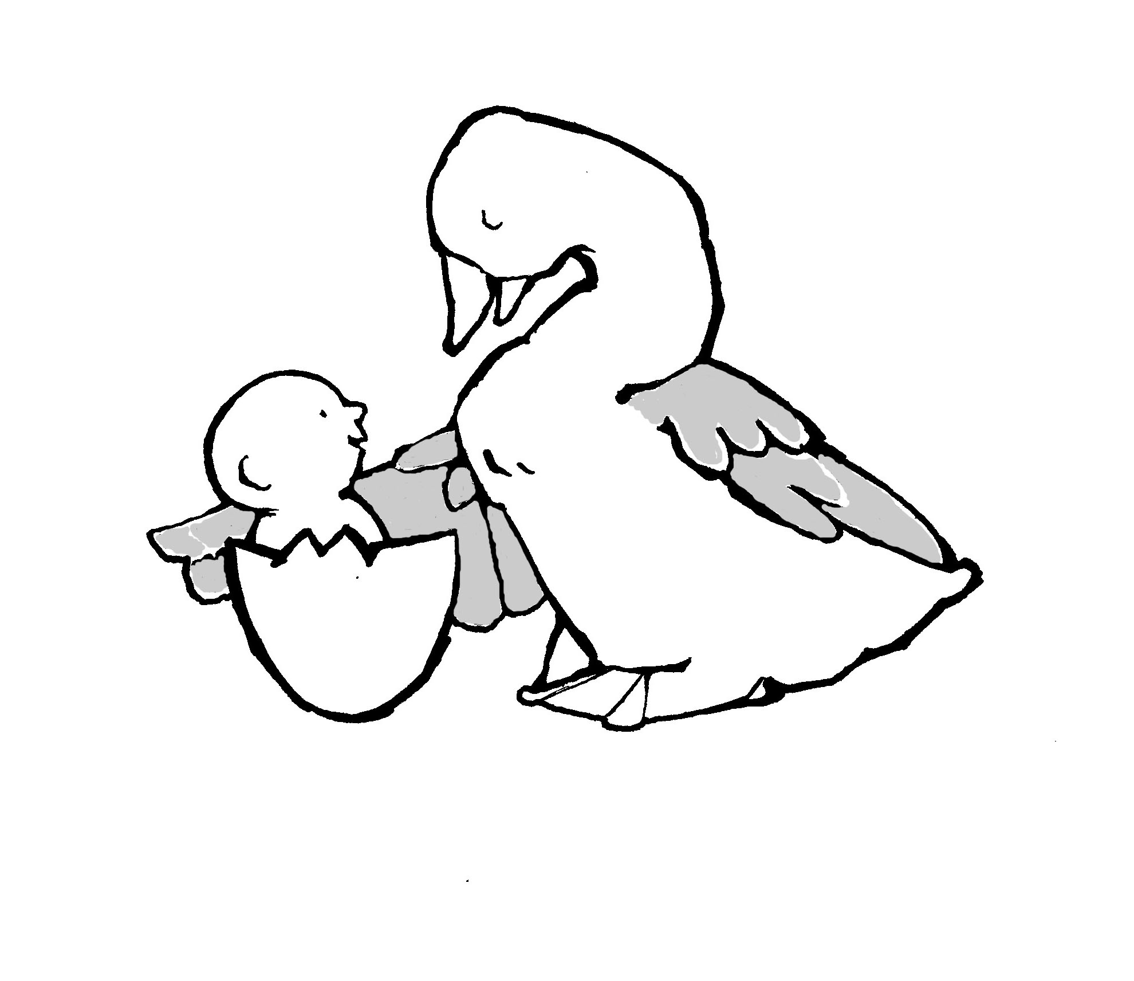
Parent-Child Mother Goose Program®
Programme la Mère l”Oie pour parents et enfants®

PROGRAM REGISTRATION FORM

To reduce paper and postage we ask that you email this form to: national@web.net Just save your completed form to your computer in Word format and attach to an email with subject heading: Program Registration Form.
You may also mail the form to: National Parent-Child Mother Goose Program® Office: 213, #200 – 5700 Yonge Street,
North York, Ontario, M2M 4K2. Other forms and information may be found at our website at: http://nationalpcmgp.ca/

Agency/Organisation Name

Mailing Address

City/Town | Province | Postal Code
Phone | Fax | E Mail
Contact person(s)

Program Teachers:

This program will be offered in partnership with another organisation. Yes No
Name(s)
The agency/organisation has paid their annual $60 membership fee: Yes No Not Sure
Membership information & forms are on our website at: http://nationalpcmgp.ca/get-involved/memberships/

Welcome to the Parent-Child Mother Goose Program family. We wish you well and look forward to receiving your reports.

