National Council of the

Parent-Child Mother Goose Program®
Annual Report 2022

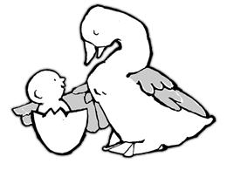
Table Of Contents

About Us 2
National Council Members 3
Report from the Co-Chairs 4
Program and Training Committee Report 6
Fundraising Committee Report 8
Diversity Council Report 10
Communication Committee Report 11
Event Planning Committee Report 12

National Parent-Child Mother Goose Program®
720 Bathurst Street, Suite 500A
Toronto, ON M5S 2R4
www.nationalpcmgp.ca

For inquiries relating to Memberships, Certification Process and Donations
please contact:
Crystal Murgatroyd
National Administrator
email: info@nationalpcmgp.ca

About Us

In the Parent-Child Mother Goose Program®, parents and young children between the ages of 0 and 4 come together to enjoy songs, rhymes and stories.

Each group of parents and children meets with two teachers once a week throughout the year. Together, parents and children in the program:
- experience the spark of delight and magic that comes from enjoying a favourite rhyme or song
- learn and retain a repertoire of rhymes, songs and stories
- enjoy strengthened bonding

These skills, pleasures and insights are taken home and shared with older children, grandparents, and other parents. The whole family benefits!

The Parent-Child Mother Goose program is preventative in nature, and provides community service agencies with a clearly developed program that is responsive to community needs.

The program is committed to inclusive services that provide a climate of mutual respect and understanding. We welcome diverse cultures, languages, family situations, sexual orientations, and physical and mental abilities.

Since its earliest beginnings, the Parent-Child Mother Goose program has since spread across Canada and around the world, helping thousands of families to discover the power and pleasure of songs, rhymes, and stories!
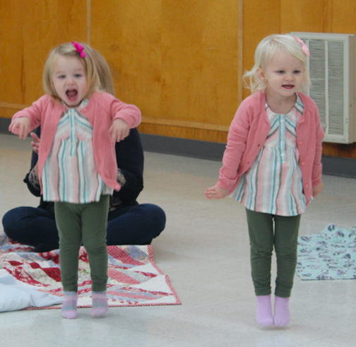

National Council Members

The management of the activities of the Parent-Child Mother Goose Program is vested in the National Council, a central unified body which addresses issues affecting the organization.

Members of the National Council, some of whom represent programs from around the country, serve as trustees for the Parent-Child Mother Goose Program to ensure organizational performance and promotion of program standards.

Carol Dwyer NL Maureen Doll BC Desrean McFarlane QC
Chantal Rodgers NL Rebecca Fenton BC Joan McDonald ON
Beth Hutchinson BC Robin Sales QC
Crystal Murgatroyd BC (Admin)

Committees and Members

- Program and Training Committee
Contact us and find out more about the rewards and benefits of contributing to PCMGP as a member of the National Council, at info@nationalpcmgp.ca
Lori Fritz
Ruth Danziger
Maureen Doll
Kate Jarrett
2. Diversity Committee
Desrean McFarlane
Lorinda Seto
Ann Stafford
Gabrielle Thomas
Beth Hutchinson

- Fundraising Committee
Beth Hutchinson
Marilee Peters
Robin Sales
Ann Stafford

- Communications Committee
Robin Sales

Report From The Co-Chairs

Dear Members,

It has been one year since we have taken over as Co-Chairs of the National Council (NC) of the Parent-Child Mother Goose Program (P-CMGP). As we reflect back on the year behind us, we would like to acknowledge and thank all current members of the NC including those who are part of our committees. We are thankful for the commitment, dedication and hard work of the NC and committee members and we are looking forward to continuing the work of connecting with members of the P-CMGPs from coast to coast.

We would like to give a special thank-you to the following NC members: Ivanka Gotcheva who recently stepped down from the NC and the Communications Committee; Desrean McFarlane will be leaving the NC, however will remain on the Diversity Council as a member; Maureen Doll will be leaving the NC at the end of the year, however, will remain as part of the Program and Training Committee. All have made valuable contributions to the NC as board members and committee members. As well, we would like to give a big thank-you to Crystal Murgatroyd, our National administrator, whose organizational skills and attention to detail shines through in all that she does for the National Council.

We would also like to recognize the staff of the Vermont Square Parent-Child Mother Goose Program in Toronto for their contributions and guidance over the years, especially as we bid a fond farewell to their executive director Susan Ryan.

As P-CMGPs across the country continue to adapt and resume after the challenges presented by the CoVid-19 pandemic, so too, does the National Council. Throughout this year we have strived to communicate, support and connect with our members, facilitators and trainers from coast to coast.

We hosted two events this past year which brought people from around the world together. The Moon is Round event, was held in February and celebrated 20 years of the National Council of the P-CMGP with many past NC members in attendance. The Once Upon a Time event, in October, celebrated 35 years of the P-CMGP and its early history. This year we also surveyed members (facilitators and trainers) to see how the National Council can best support them in the future. Most members are in favor of connecting through events like those mentioned above, as well as with each other through rhymes, songs and stories and for discussion. We are currently working on updating the NC Mission Statement to clarify our role in supporting facilitators and trainers in Canada.

As we look forward to the year ahead we will continue to recruit new members from all around the country. We will continue our fundraising efforts to support our administrator and all she does for the P-CMGPs. We will renew our efforts to provide support to our P-CMGP facilitators, trainers and members while continuing to strengthen relationships with partner agencies, and diversify our representation across the country.
As we move forward post-pandemic, we would like to congratulate all of the facilitators, trainers and organizations who continue to run programs and support families throughout the country. All the best for the year ahead.

Warm regards,
Chantal Rodgers and Carol Dwyer
Co-Chairs, National Council of Parent-Child Mother Goose Program®

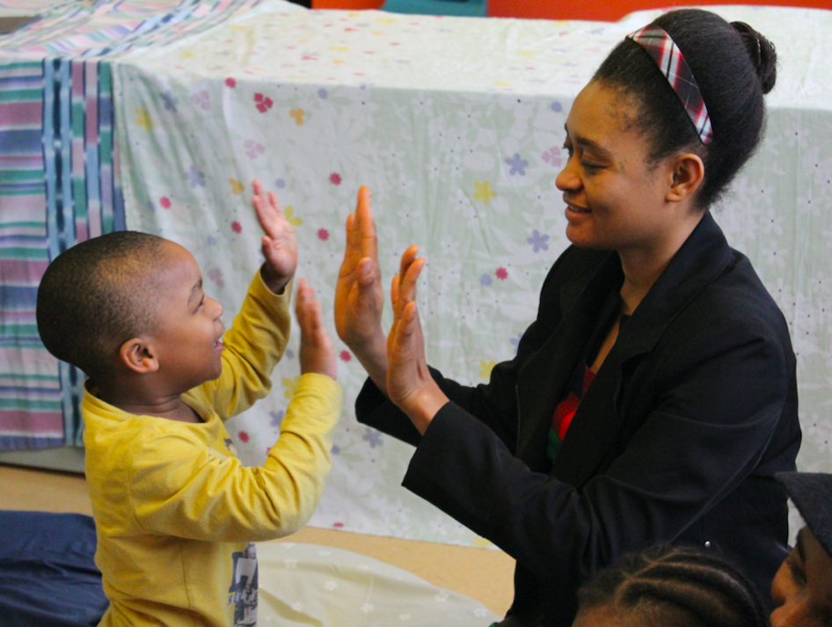

Program and Training Committee Report

The Program and Training Committee is a committee of the National Council that focuses on all aspects of our program and training guidelines, development, and policy. It has been a full year of activity from around the country.
In January 2022 we held the sixth annual meeting for P-CMGP teacher trainers, over two different days and times to accommodate as many trainers as possible via Zoom. We thoroughly enjoyed being able to put faces to names and vice versa.
Questions posed were: This year we have continued to offer virtual teacher training workshops. Please let us know what is working well for you, and/or are there barriers, questions or concerns? How can we support you? Would you like to see virtual training sessions be an option?
There was a lot of discussion and comments regarding the positives and challenges of virtual teacher training. The positives included the opportunity to have participants from all over Canada in the same group, the cost saved due to not needing to travel and the luxury of being able to be at home for the training sessions.
The challenges included the missed opportunity for physical connection and learning material together in person. There is such power and joy that comes from experiencing the materials together.
The committee would like to extend our sincerest gratitude to all those that attended these meetings and for all the reflection that occurred.
Much of 2022 has been spent updating Teacher Training Workshop (TTW) Level 1 materials to make them more user friendly, accessible online and current. We have finalized the loose-leaf forms, the yellow booklet and are in the final stages of the green lyric booklet and bibliography. Thank you to the Diversity Committee for your thoughtful feedback regarding the lyric booklet.
In addition, an ongoing effort to translate documents from these materials into French continued. A huge thank-you to Marie-Line Therriault for contributing her skills as a volunteer translator during 2021-22, and her commitment to this project. Marie-Line also developed and sustained our online Francophone workshops this year.
2022 was a busy year for welcoming 3 new TTW Level 1 Workshop Facilitators. Guita Movallali, ran the PCMG programs for deaf and hard of hearing children and their families in Iran for 10 years. We are fortunate that she moved to Toronto last year and is now contributing her skills, energy and enthusiasm to programs in Canada. Guita mentored with Ruth Danziger, Lynda Howes and Maria Ordonez. Welcome Guita.
Maureen Doll mentored Jo Lukawitski, from the Yukon. Jo is a long-time teacher within the Parent-Child Mother Goose Program® and has a ton of passion and creativity when working with families. Jo will be a huge asset for expanding the program in the Yukon and NWT. Welcome Jo.
Lisa Hurrle, is a well-known name within the Parent-Child Mother Goose Program® community. Lisa has served on the National Council and recently became a TTW Level 1 leader. She mentored with Ginger Mullen, Lynda Howes and Maureen Doll. Lisa lives in Alberta and is also a teacher with the P-CMGP. Welcome Lisa.
In October the P & T committee updated the committee mandate. This had not been done in over 10 years so was ready for a good refresh.
Finally, we are working on establishing a generic Program and Training email address that can be used for inquiries and sending reports to. Stay tuned for the new email.
As always, we continue to respond to questions and communications that come our way from across the country and abroad, relating to Program and/or Training guidelines. We appreciate the opportunity to hear of the positive changes that the Parent-Child Mother Goose Program® makes in the lives of families!
We welcome ideas, questions, and feedback from our P-CMGP community.
Please feel free to contact us at any time☺
Program and Training Committee:
Ruth Danziger, Ontario rdanziger@ca.inter.net
Lori Fritz, Newfoundland/Ontario lorellfritz@gmail.com
Kate Jarrett, Ontario kate.jarrett@sympatico.ca
Maureen Doll, BC moesdoll@gmail.com


Thumb in the thumb place
Fingers all together
This is the song we sing
In the mitten weather

Fundraising Committee Report

We are happy to report that donations have been increasing so far in this fiscal year:

July 2020 – June, 2021 donations: $3,315
July 2021 – June, 2022 donations: $1448, notice the Covid hit.
July to October 22, 2022: $2,147

Memberships

July – June 2021 Memberships: $ 3105
July – June 2022 Memberships: $ 3,879
2022 Memberships, July to October: $170 (Most membership renewals are made at the beginning of the calendar year.)

Our Work

We met monthly, developed a fundraising calendar, sent out two fundraising letters in 2021 and three in 2022, explored grant possibilities, Beth attended a fundraising short course through Canada Helps, and we did not give up!

We are exploring other funding options. We applied for an award that had a lovely big cash prize; we did not win.

As previously mentioned, in this year, the National Council held two national events online. They were held primarily for appreciation, for celebration and for providing a knowledge of the history of the program. They were both free events, with donations welcome. We were delighted that both did generate donations!

We now have five monthly donors and matching funds for monthly donations for the first $1,000. We plan to attempt to find continued matching funding for monthly donations. Our current monthly donations range from $10 up to $20 per month. All of you are very welcome to make a monthly donation for any amount from $3 upwards (Canada Helps low limit). The Donate button on the website takes you to a donation form and a monthly donation option is provided there. As this system of donating grows, we expect it to cover a reliable chunk of our monthly financial needs. Monthly donations are a tremendous bonus for non-profit agencies.

We are looking at potential grant options for the coming year.

We will continue to explore other potential sources of funds. We are very pleased to be in a better financial position at this moment than we were at this time last year, however, we could certainly be doing a lot more if we had more substantial funds.

To wind up, we would like to say that the Parent-Child Mother Goose Program® is a fabulous program!
It provides a boost to the relationship between parent and child; there is nothing of more lasting importance in the life of a child than this!

It also boosts abilities and confidence for both parent and child. It reduces isolation for all involved: connections spread beyond the program and many last for years.

AND, the love of stories, of rhymes and songs stays with a person throughout their lives, a treasury of both strength and joy!

Therefore, please DONATE!

Robin Sales
Marilee Peters
Ann Stafford
Beth Hutchinson

We welcome new members. The requirements are a commitment to the Parent-Child Mother Goose Program National Council and an interest in fundraising.

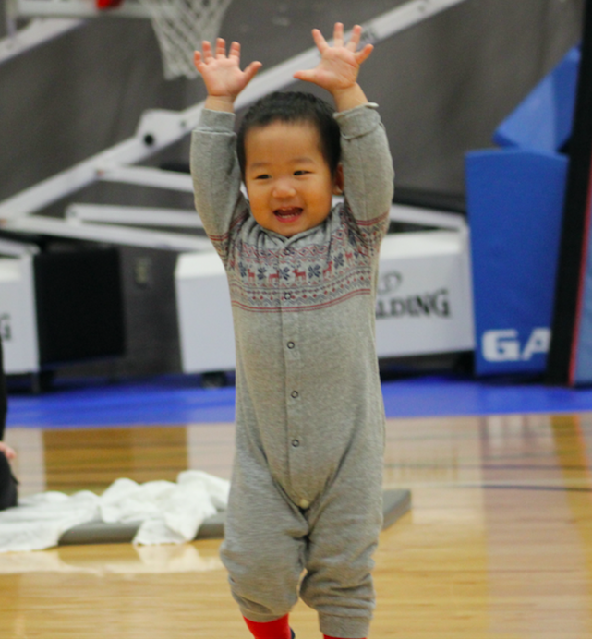

Diversity Council Report

We have loved our work! It is so interesting to share perspectives, to learn from each other and to consider what might be helpful to the PCMGP as a whole.

Since the last AGM, we
- finished off the review of the rhymes and songs provided to training workshop participants.
- reviewed the availability in libraries of bibliography resources provided to training workshop participants
- developed a suggested introduction to that collection of rhymes and songs encouraging program teachers to encourage parents to adapt rhymes and songs to the specific needs of their child, the moment and themselves.
- suggested edits to the statement of diversity that had been developed previously by trainers and the Program and Training Committee.
These have been submitted to the Program and Training Committee.

We hope to look now at finding ways for program trainers to share their approaches to encouraging diversity with each other, to build connections amongst Indigenous program teachers and to learn from them, to encourage the diversity of participants in other PCMGP NC committees and the Council itself, and to highlight stories that reflect diversity in PCMGPs.

Most of our work is done in conjunction with the Program and Training Committee.

As we are the most diverse of any of the National committees and the council itself, we have decided that it is important to continue as a committee and to find ways to continue building the inclusive capacity of the program.

Desrean McFarlane
Lorinda Seto
Ann Stafford
Gabrielle Thomas
Beth Hutchinson

At the end of the fiscal year, Kate Jarrett and Noemi Stafford were also committee members. Since that time, they have both left due to heavy demands of other work. Kate was a member of this committee and the Program and Training Committee.

We welcome new members. A commitment to the National PCMGP is required. We particularly want representation from cultures, races and geographical locations not currently part of the committee.

Communications Committee Report

Newsletters have been produced and distributed during 2022. However, we did not produce one in the Fall as one of our committee members, rIvanka Gotcheva resigned. We are working to re-establish the newsletter in an updated format.
Anyone who is interested in being involved in the work or with ideas about the best kind of newsletter for us to have is very welcome to contact us at info@nationalpcmgp.ca.

Robin Sales

The Moon is round
As round can be
Two eyes, a nose
And a mouth like me

The Moon is Round event, held over Zoom in February, celebrated 20 years of the National Council of the P-CMGP. Brief presentations were done by previous NC chair persons, Glenna Janzen, Dana Brynelsen, Dianne Blewett, and Marilee Peters as well as by Celia Lottridge. In addition, numerous facilitators from around the country shared both rhymes and songs during the event. Seventy-five people registered to attend.The Once Upon a Time event, was held in October on Zoom and it celebrated 35 years of the P-CMGP and its early history. Special guests were Barry and Dinny Dickson, Celia Lottridge and Katherine Grier. It was a wonderful discussion from all four presenters about how the idea for the program started and how it developed and became the nationwide program that it is today. There were seventy people registered to attend the event, including 3 people from Australia Parent-Child Mother Goose Programs. The event was recorded and edits have been made and it is ready for release. We are currently working on how best to release it. Peter ??? from Australia has kindly offered to review the edited video and do a written compilation of the information that was discussed so that we can have it preserved.
Event Planning Committee Report

Both events were successful in connecting people who had vested interest in the P-CMGP.

Carol Dwyer
Beth Hutchinson
Robin Sales
Susan Ryan

Diversity Council Report

